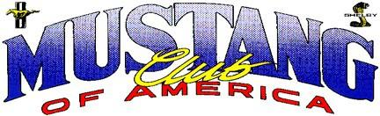

Earn a total of 100 points in any combination in the calendar year of 2025 and the 2025 PRESIDENT’S AWARD will be presented to your club. The goal is for every Regional Club to win this award. Please complete and submit by July 1, 2026.

Item Points Documentation Requirements

Monthly Newsletter (one) Attach a copy

10

Parade (one) Attach pictures or article

10

100% MCA Membership 20 Membership listing with MCA numbers News for Mustang Times or Mustang.org 10 Copy of article/date submitted

10
Host a local regional show or track event Flyer, publication article or date Insurance requested

Apply for National show 10 Copy of National show application

Sponsor local charity ea Newspaper article or publicity information

10

Every Five new Regional Club members 10 Membership listing with enrollment dates

Attend the National Judges meeting 10 Member’s MCA number and name (five maximum) Attend MCA Board meeting or Summit 15 President or Regional Directors Name/MCA number
Enter vehicle in National or GN Show Member’s MCA number and name (five maximum)

10

Car in Mustang Times or Mustang.org 10 Copy of article

Article on a Regional meeting 10 Supply copy from newspaper, Mustang Times or Mustang.org

Sponsor a Cruise Night (one) 10 Copy of publicity flier

Gold Card Judge 10 ea Member’s MCA number and name Every Three Certified Judges 10 Member’s MCA numbers and names New MCA members 2 ea Member’s MCA numbers and names

Regional Club: Date: Contact Person/Title: Phone: Address: City: ST: Zip: E-mail

Check preference for awarding ( Final Show) Regional Directors Summit) Mail) Mail to: MCA
___
( ___
( ___
– PO Box 3973, Suwanee, GA 30024- Phone (850) 438-0626 or scan and email to mcaofficeadministrator@mustang.org

